Test Case: tc003_SPX_Dev5_Crear_Requisicion_Spot_Tipo_Cobro_CC_Urgent
Step 1 - Enter username and password and click to button Enter : Credentials Entered
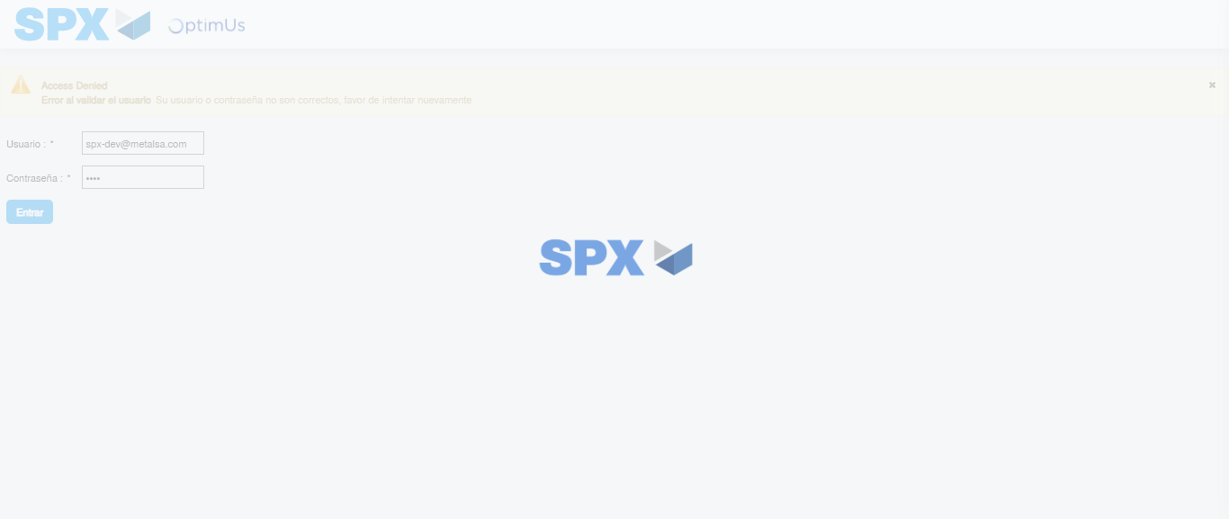Image file-name: QC_Testing-tc003_SPX_Dev5_Crear_Requisicion_Spot_Tipo_Cobro_CC_Urgent-1785961633372

Step 2 - Select to UEN and Access to Spot Buy Requisitions : UEN Correctly selected and Correct access
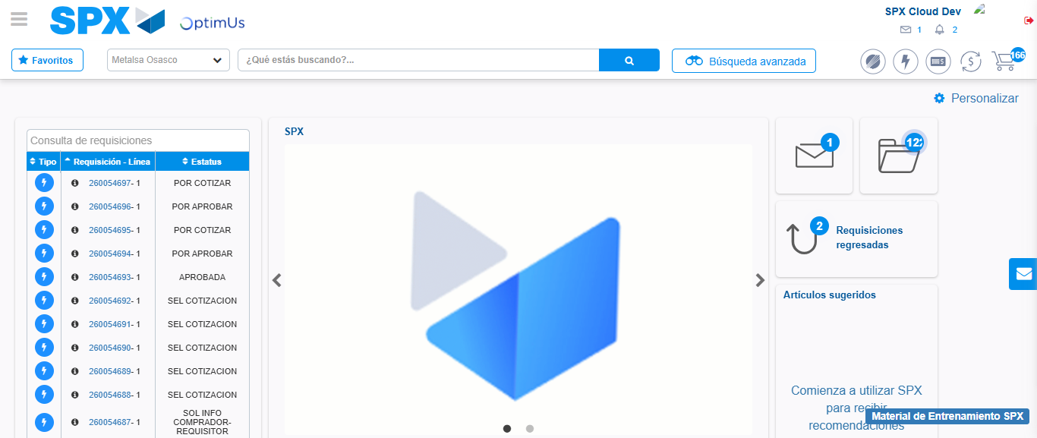Image file-name: QC_Testing-tc003_SPX_Dev5_Crear_Requisicion_Spot_Tipo_Cobro_CC_Urgent-1785961658851

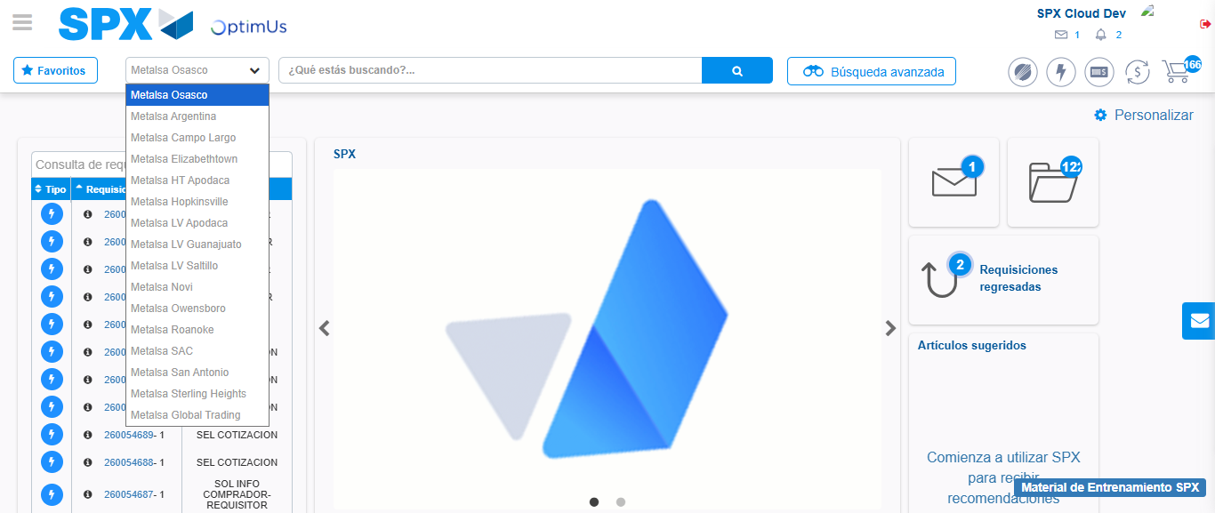Image file-name: QC_Testing-tc003_SPX_Dev5_Crear_Requisicion_Spot_Tipo_Cobro_CC_Urgent-1785961661409

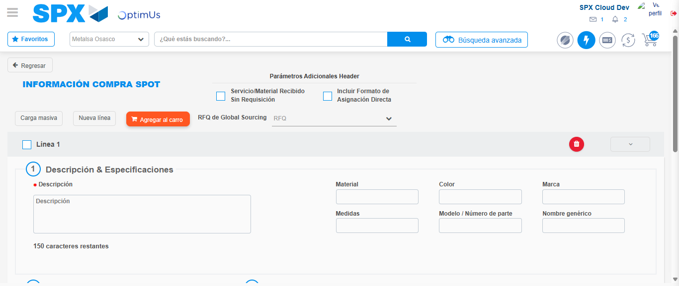Image file-name: QC_Testing-tc003_SPX_Dev5_Crear_Requisicion_Spot_Tipo_Cobro_CC_Urgent-1785961668966

Step 3 - Data Capture Spot Buy Requisition: Data captured correctly
Image file-name: QC_Testing-tc003_SPX_Dev5_Crear_Requisicion_Spot_Tipo_Cobro_CC_Urgent-1785961669200

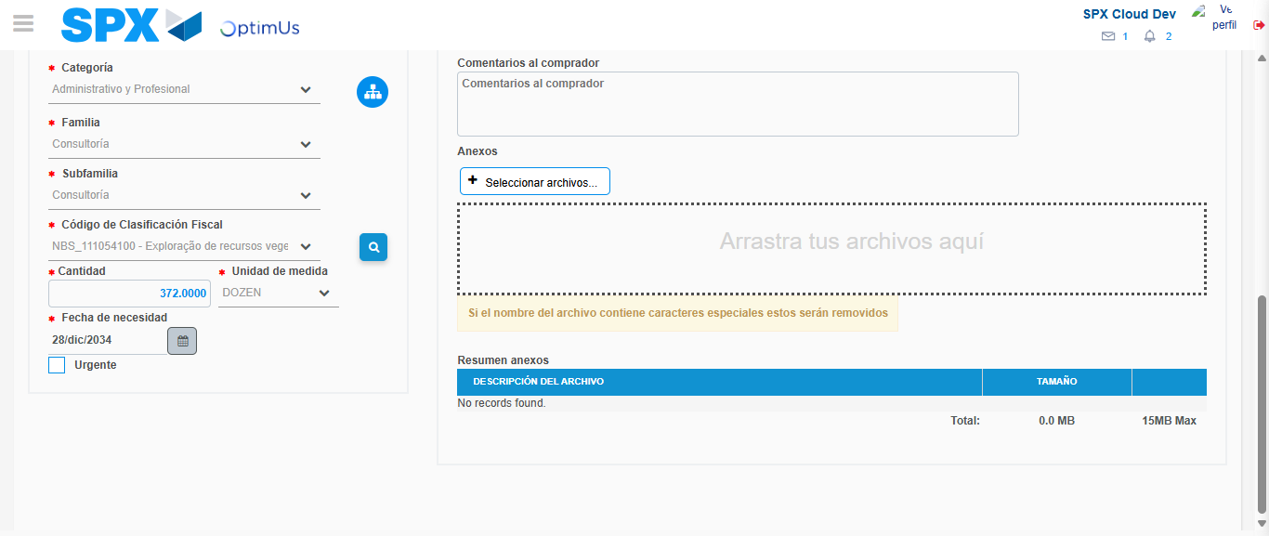Image file-name: QC_Testing-tc003_SPX_Dev5_Crear_Requisicion_Spot_Tipo_Cobro_CC_Urgent-1785961684736

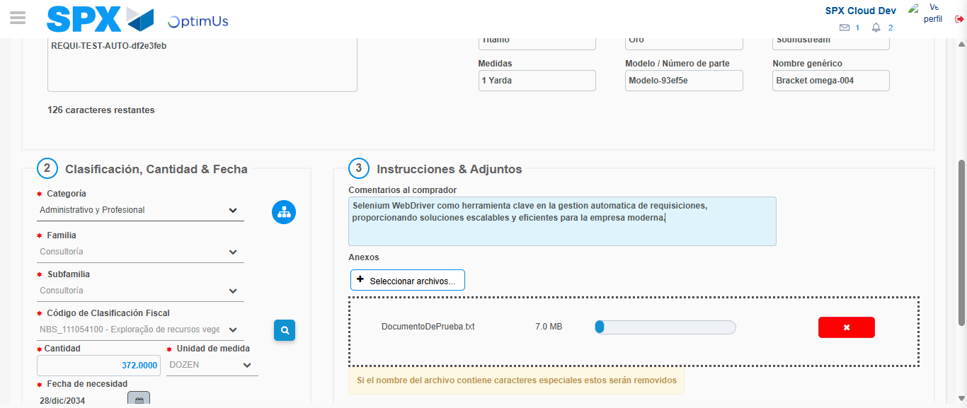Image file-name: QC_Testing-tc003_SPX_Dev5_Crear_Requisicion_Spot_Tipo_Cobro_CC_Urgent-1785961685481

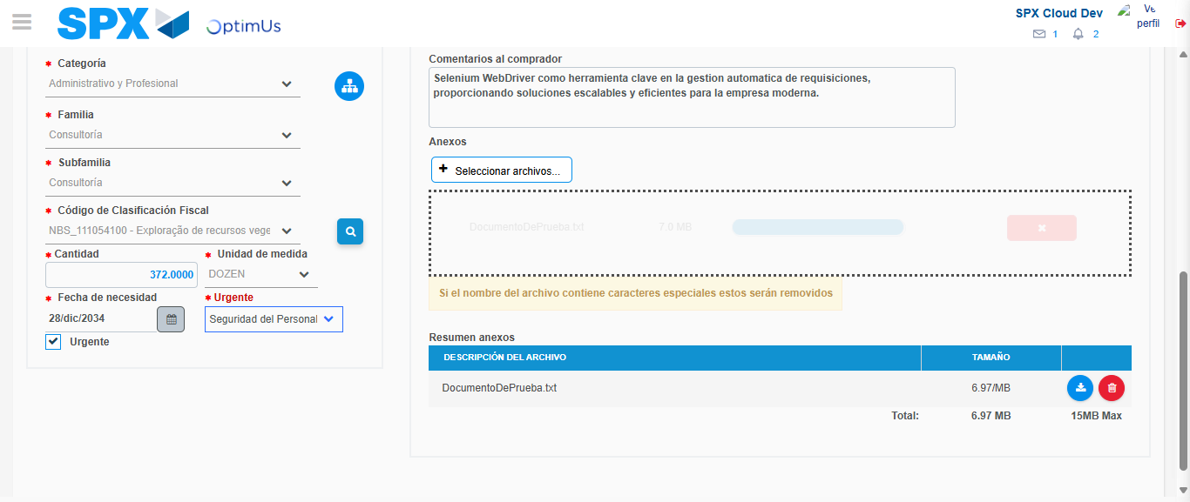Image file-name: QC_Testing-tc003_SPX_Dev5_Crear_Requisicion_Spot_Tipo_Cobro_CC_Urgent-1785961689659

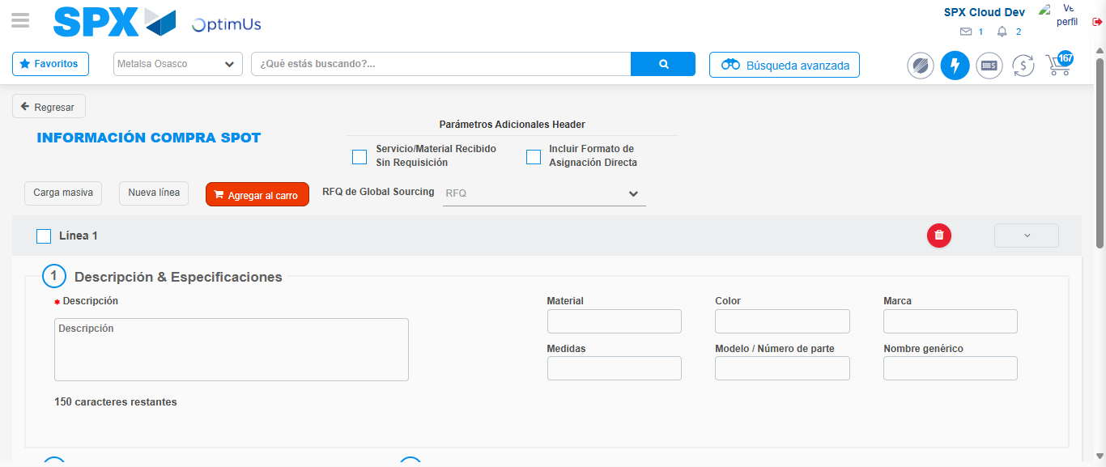Image file-name: QC_Testing-tc003_SPX_Dev5_Crear_Requisicion_Spot_Tipo_Cobro_CC_Urgent-1785961704366

Step 7 - Return to Main Page SPX : Return to Main Page SPX
Image file-name: QC_Testing-tc003_SPX_Dev5_Crear_Requisicion_Spot_Tipo_Cobro_CC_Urgent-1785961658851

Image file-name: QC_Testing-tc003_SPX_Dev5_Crear_Requisicion_Spot_Tipo_Cobro_CC_Urgent-1785961661409

Image file-name: QC_Testing-tc003_SPX_Dev5_Crear_Requisicion_Spot_Tipo_Cobro_CC_Urgent-1785961668966

Image file-name: QC_Testing-tc003_SPX_Dev5_Crear_Requisicion_Spot_Tipo_Cobro_CC_Urgent-1785961706579

Image file-name: QC_Testing-tc003_SPX_Dev5_Crear_Requisicion_Spot_Tipo_Cobro_CC_Urgent-1785961706712

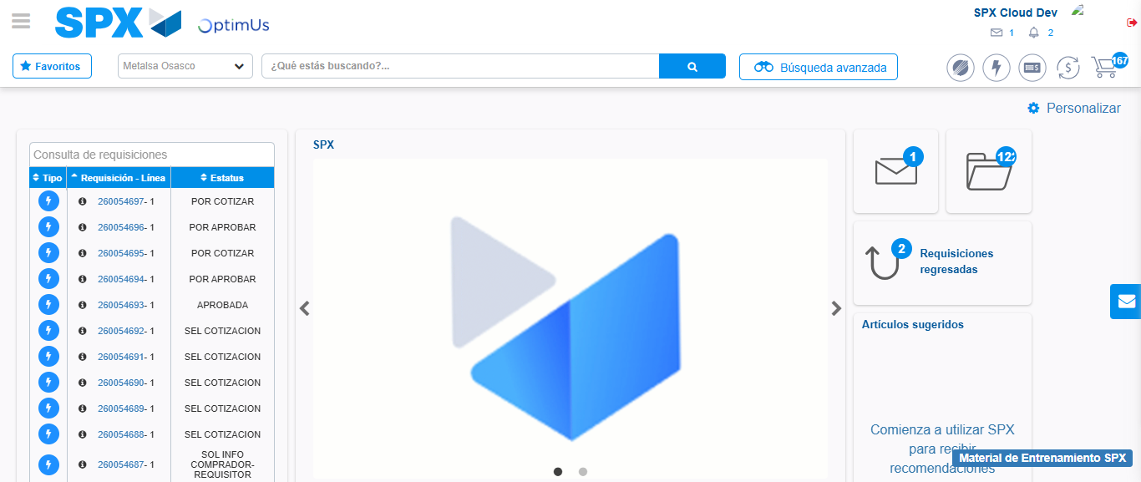Image file-name: QC_Testing-tc003_SPX_Dev5_Crear_Requisicion_Spot_Tipo_Cobro_CC_Urgent-1785961727775

Step 8 - Log Out : Log Out SPX
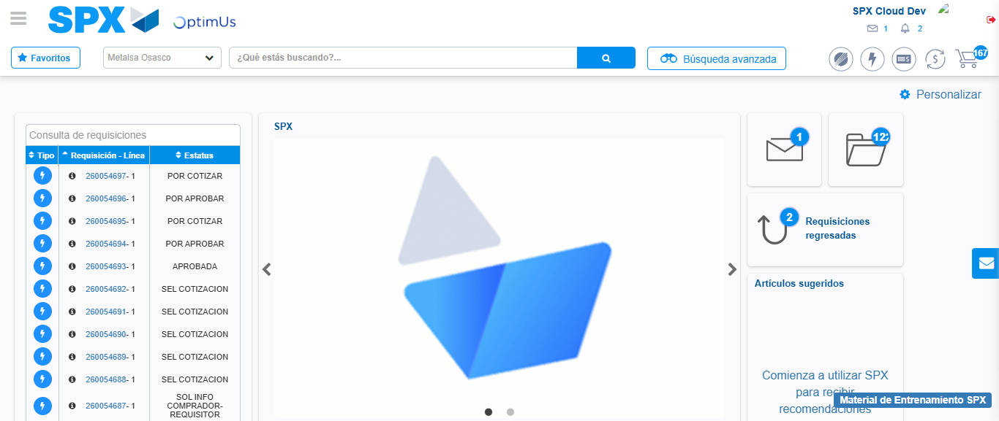Image file-name: QC_Testing-tc003_SPX_Dev5_Crear_Requisicion_Spot_Tipo_Cobro_CC_Urgent-1785961728072

